**ST. THEREZA NAMIRYANGO GIRLS’ BOARDING PRIMARY SCHOOL**

**END OF TERM I CONTINUOUS ASSESSMENT 2024**

**P.3 LITERACY**

**TIME ALLOWED: 2 HOURS 15 MINUTES**

**NAME___________________________________________STM__**

**SECTION: A (40 MARKS)**

1. Name one example of a domestic bird.

**_______________________________________________________**

2. Write one thing found in a sitting room.

**_______________________________________________________**

3. Draw the map of this picture.



4. Why do people carryout rabbit keeping?

**_______________________________________________________**

5. Why do people in a homestead need a kitchen?

**_______________________________________________________**

6. What is a calf?

**_______________________________________________________**

7. Why is a school called an important place?

**_______________________________________________________**

8. How can people control drought?

**_______________________________________________________**

9. State one use of swamps in our Town Council.

**_______________________________________________________**

10. Mention any one skill taught to children in Primary Schools in Uganda.

**______________________________________________________**

11. How best can a P.3 pupil use harvest rain water?

**_______________________________________________________**

12. Mention the largest ethnic group of people in our Town

Council.

**_____________________________________________________**

13. Draw a pair of gloves used by medical workers.

14. Why should people do economic activities?

**_____________________________________________________**

15. How is jogging important to a person?

**_____________________________________________________**

16. How can people keep peace in our community?

**_____________________________________________________**

17. Why does a carpenter need the tool shown below.

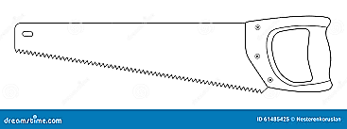

**______________________________________________________**

18. Why is the Headgirl important in our school?

**______________________________________________________**

19. Write one effect of child abuse practices.

**______________________________________________________**

20. State one reason for having picnics.

**______________________________________________________**

21. Write one way of greeting people.

**______________________________________________________**

22. How is shelter useful to people?

**______________________________________________________**

23. What is education?

**______________________________________________________**

24. Draw one thing made from plastics.

25. Why is Luganda mostly used in our Town Council?

**______________________________________________________**

26. How can pupils protect themselves from the type of

weather shown below?

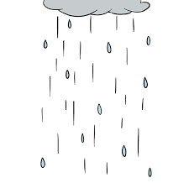

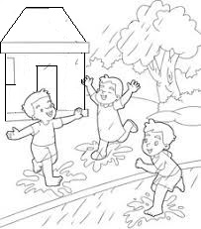

**______________________________________________________**

27. Why should people protect rivers?

**______________________________________________________**

28. Why does our community need police officers?

**______________________________________________________**

29. Why do people need bicycles?

**_____________________________________________________**

30. Name the cardinal point marked Y on the compass

direction below.

**N**

**Y**

**B**

**South**

**_________________**

31. Where should people go for a nature’s call?

**_____________________________________________________**

32. Mention any one part of the body ENT-Specialists treat.

**_____________________________________________________**

33. How is playing on the road dangerous to children?

**_____________________________________________________**

34. What do you learn from our school motto?

**_____________________________________________________**

35. Why should you keep your school uniform clean?

**_____________________________________________________**

**Religious Education**

36. What do you learn from Moses as a good leader?

**_____________________________________________________**

37. Who is a leader?

**_____________________________________________________**

38. Name the God’s creation shown below.



**________________________**

39. How can you behave well during time for players?

**_____________________________________________________**

40. Why did God save Noah and his family?

**_____________________________________________________**

**SECTION: B (60 MARKS)**

41. Match the social service provider to the social service.

**Social service provider Social service**

ship captain education service

doctor security service

teacher health service

soldier transport service

42a) Draw the following physical features.

|  |  |  |
| --- | --- | --- |
|  |  |  |
| a hill | a valley | a plateau |

b) Why is it bad to build houses in swampy areas?

**____________________________________________________**

43a) What do these map symbols mean?

1. **_____________**

ii) **______________**

iii) **_____________**

b) Write one element of a good map.

**____________________________________________________**

44. **Complete the table below correctly.**

|  |  |
| --- | --- |
| **Tribe** | **Language** |
| Baganda | **_____________** |
| **___________** | Ng’Karamojong |
| **___________** | Luo |
| Banyoro | **____________** |

45(a) What is a kitchen?

**_____________________________________________________**

(b) How is firewood useful to a cook?

**_____________________________________________________**

(c) How can people keep their kitchens clean?

**____________________________________________________**

(d) Draw a picture of a mortar in the space provided below.

46(a) What is an accident?

**_____________________________________________________**

(b) Why is it bad to play with electrical appliances?

**_____________________________________________________**

(c) Mention any two effects of accidents.

i)**________________________________________________________**

ii) **_______________________________________________________**

47(a) What do we call the habitat of a cat?

**_____________________________________________________**

(b) How can people care for chicks?

**_____________________________________________________**

(c) State two ways of keeping animal habitats clean.

i)**________________________________________________________**

ii) **_______________________________________________________**

48(a) What are social insects?

**_____________________________________________________**

(b) How are bees dangerous to people?

**____________________________________________________**

(c) Draw the habitat of whiteants and termites in the space below.

(d) How are whiteants useful to people?

**____________________________________________________**

49. **Study the diagram below and answer the questions that follow.**

**Grandfather** **Grandmother**

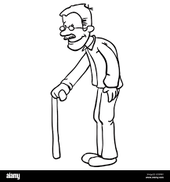 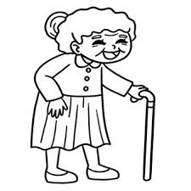

Mother Father

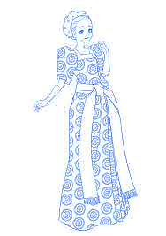 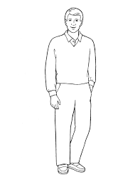

**Mr. Opeto**

**Mrs. Opeto**

Daughter

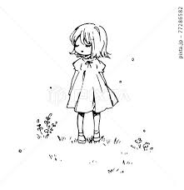

**Lucy**

(a) What type of family is shown above?

**___________________________________________________**

(b) What does Lucy call the father to her father?

**____________________________________________________**

(c) How can Mr. and Mrs. Opeto help their parents to live happily?

**____________________________________________________**

(d) State one role of Lucy in the above family.

**_____________________________________________________**

50(a) State two roles of leaders in our Town Council.

i)**________________________________________________________**

ii) **_______________________________________________________**

(b) How can people show respect to leaders in our Town Council?

i)**________________________________________________________**

ii) **_______________________________________________________**

**Religious Education**

51(a) How did Jesus meet people’s needs in the Bible?

i)**________________________________________________________**

ii) **_______________________________________________________**

(b) State two ways of showing love to fellow people.

i)**________________________________________________________**

ii) **_______________________________________________________**

52(a) Why is God called Protector?

**_____________________________________________________**

(b) Mention two local names of God.

i)**________________________________________________________**

ii) **_______________________________________________________**

(c) Why do you worship God?

**_____________________________________________________**

53. **Match the following correctly.**

1. Joseph of Arimathea denied Jesus Christ
2. Judas Iscariot buried the body of Jesus Christ
3. Pontius Pilate betrayed Jesus Christ
4. Simon Peter sentenced Jesus Christ to death

**Correct order**

1. Joseph of Arimathea **______________________________________**
2. Judas Iscariot **_____________________________________________**
3. Pontius Pilate **_____________________________________________**
4. Simon Peter **_______________________________________________**

54(a) Mention any two messengers of God in the Bible.

i)**________________________________________________________**

ii) **_______________________________________________________**

(b) Write any two lessons you learn from God’s messengers.

i)**________________________________________________________**

ii) **_______________________________________________________**

55(a) “Let there be light.” Who said the above words?

**____________________________________________________**

(b) Mention any two created living things.

i)**________________________________________________________**

ii) **_______________________________________________________**

(c) Why did God create the moon?

**____________________________________________________**

**End**